Activity 3.4: Chatbot aka ‘Cat Bot’
You are going to create a chatbot. A chatbot is a program that asks a question and then uses the answer to the question in its next question. Here is an example:
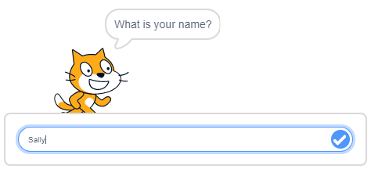
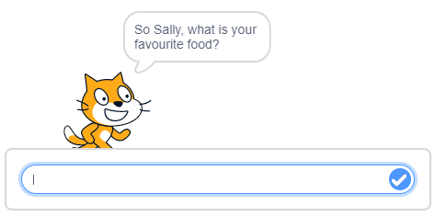
Create a chatbot that asks five questions; the questions it asks are up to you, but we would like you to start with What is your name? The chatbot must use the response from each question to make a comment or feed into the next question.
At the end of the five questions, the chatbot needs to say Thank you for talking to me, followed by the user’s name.

Here are success criteria to help you break the problem down.
Success criteria | Met?
Is the first question What is your name?
Does the chatbot ask the user five questions about themselves in total?
Does the chatbot use the answer from each question to make a comment or feed into the next question?
Does the chatbot finish by saying Thank you for talking to me, followed by the user’s name.
Have variables been used?

HINT: You will need to make use of a variable to store the user’s name when it is entered in response to the first question.
Don’t forget to screenshot your blocks and paste the screenshot into your evidence document.
Extension activity
Can you improve your chatbot so that, when the five questions have been answered, it provides a summary of all the information entered? Here is an example:
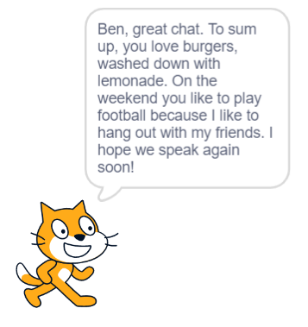
Remember to screenshot your blocks and paste the screenshot into your evidence document.

